**PROJECT REPORT**

**IBM-Project-23259-165987493**

**TITLE:**

Skill / Job Recommender Application

**MENTOR:**

Mr. AZARUDEEN, M.E.,

**TEAM LEADER:**

RAMYA V

**TEAM MEMBERS**

SUBHASHREE S

SREE KRISHNA B

KIRTHANA B

**TEAM ID:**

PNT2022TMID23044

|  |  |
| --- | --- |
| **TABLE OF CONTENTS** | **PAGE NO** |
| 1. **INTRODUCTION**   1.1 Project Overview  1.2 Purpose | **1** **2** |
| 1. **LITERATURE SURVEY**   2.1 Existing problem  2.2 References  2.3 Problem Statement Definition | **15** **16** **16** |
| 1. **IDEATION & PROPOSED SOLUTION**   3.1 Empathy Map Canvas  3.2 Ideation & Brainstorming  3.3 Proposed Solution  3.4 Problem Solution fit | **17** **18** **22** **24** |
| 1. **REQUIREMENT ANALYSIS**   4.1 Functional requirement  4.2 Non-Functional requirements | **25** **25** |
| 1. **PROJECT DESIGN**   5.1 Data Flow Diagrams  5.2 Solution & Technical Architecture  5.3 User Stories | **26** **26** **27** |
| 1. **PROJECT PLANNING & SCHEDULING**   6.1 Sprint Planning & Estimation  6.2 Sprint Delivery Schedule | **28** **29** |
| 1. **CODING & SOLUTIONING**   7.1 Home Page  7.2 Register Page  7.3 Login Page  7.4 Dashboard  7.5 Job Apply Page  7.6 Recommendation Page | **30** **37** **45** **55** **63** **70** |
| 1. **TESTING**   8.1 Test Cases  8.2 User Acceptance Testing | **81** **82** |
| 1. **RESULTS**   9.1 Performance Metrics | **83** |
| 1. **ADVANTAGES & DISADVANTAGES** | **84** |
| 1. **CONCLUSION** | **84** |
| 1. **FUTURE SCOPE** | **85** |
| 1. **APPENDIX** | **85** |

**1.INTRODUCTION**

Nowadays, job search is a task commonly done on the Internet using job search engine sites like LinkedIn, Indeed and others. Commonly a job seeker has two ways to search a job using these sites doing a query based on keywords related to the job vacancy that he/she is looking for or creating or updating a professional proﬁle containing data related to his/her education professional experience professional skills and other, and receive personalized job recommendations based on this data. Sites providing support to the former case are more popular and have a simpler structure; however, their recommendations are less accurate than those of the sites using proﬁle data. Personalized job recommendation sites implemented a variety of types of recommender systems, such as content-based ﬁltering, collaborative ﬁltering, knowledge-based and hybrid approaches Moreover to make the job-seekers useful and utilize them with wonderful features.

**1.1PROJECT OVERVIEW**:

Job recommender systems have become popular since they successfully reduce information overload by generating personal-ized job suggestions. Although in the literature exists a variety of techniques and strategies used as part of job recommender systems, most of them fail to recommending job vacancies that fit properly to the job seekers profiles. Thus, the contributions of this work are threefold, we made publicly available a new dataset formed by a set of job seekers profiles and a set of job vacancies collected from different job search engine sites put forward the proposal of a framework for job recommendation based on professional skills of job seekers; and carried out an evaluation to quantify empirically the recommendation abilities of two state-of-the-art methods, considering different configurations, within the proposed framework. We thus present a general panorama of job recommendation task aiming to facilitate research and real-world application design regarding this important issue.

**1.2 PURPOSE:**

The significance of Skill and Job recommender system support in the recruitment process can be observed when considering the phases of the recruitment. It makes easier for the candidate to select which job is best fit for his/her profile

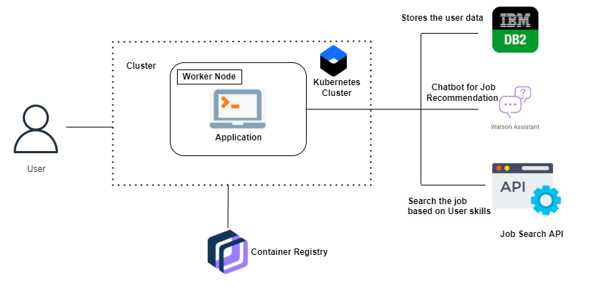

**2.LITERATURE SURVEY**

**Survey Paper-1**

**Author:**

* Willy Wize A.Z
* Gati Gayatri

**Title:** The Dynamic of Digital Skills Demands-an Analysis on Three Job Marketplace Platforms

**Published Journal:** IEEE

**Published Month:** October

**Published Year:** 2021

**Objective:**

Ensuring rural communities to have an equal chance with urban communities in developing their digital skills is a great challenge. The challenge is much greater in the situation of fast advancing digital technology and of lacking ICT infrastructure in rural areas. Our objective is to suggest skills to the rural communities based on the job they want to do.

**Critical Findings:**

**Merits:**

Everyone irrespective of rural and urban can have equal opportunity to develop their skill to achieve their goal.

**Demerits:**

It can also have disruptive effects, with the marginalization of actors that cannot cope with the change. When developing a novel system for rural areas, requirements engineers should carefully consider the specific socio-economic characteristics of the domain

**Survey Paper-2**

**Author**:

* Saju Mohanan
* Sunitha Cheriyan
* R. K. Rajesh

**Title:**

Deploying Smart Academy: A cloud integrated methodology todevelop smart IT graduates to meet the ICT enabled industrial needs in Middle East

**Published Journal:** IEEE

**Published Month**: August

**Published Year: 2017**

**Objective:**

Cloud computing is becoming as an imperative element for any organizational setup, as a service based cloud model to meet the education oriented technological needs of academic institutions.This paper tells a model based approach to equip the students to improve their skills based on needs of the industrial standards. This will help in the improvement of the current educational system and it will balance the requirements of the industrial jobs.

**Critical Findings:**

**Merits:**

Helps to improve skills based on current industrial standards.

**Demerits:**

One of the demerits of skill based training is if that particular technology gets down in future, the individual can’t go for other job.

**Survey Paper-3**

**Author:**

* Amber Nigam
* Aakash Roy
* Hartaran Singh

**Title:** Job Recommendation through Progression of Job Selection

**Published Journal:** IEEE

**Published Month:** December

**Published Year:** 2019

**Objective:**

Introducing a novel machine learning model which uses the candidates job preference to incorporate the dynamics associated with highly volatile job market. The model has been developed and deployed in a real-world job recommender system and the best performance of the click-through rate metric has been achieved through a blend of machine learning and non-machine learning recommendations.

**Critical Findings**:

**Merits:**

It generates serendipitous recommendations and solves the cold-start problem for new jobs and new candidates.

**Demerits:**

Analysing large amount of data and storing data is tedious to maintain.

**Survey Paper-4**

**Author:**

• Nikolaos D. Almalis

• George A. Tsihrintzis

• Nikolaos Karagiannis

**Title:** A content based approach for recommending personnel for job positions

**Published Journal:** IEEE

**Published Month:** July

**Published Year:**2014

**Objective:**

A content-based approach that takes into consideration an organization's needs and the skills of candidate employees in orderto quantify the suitability of a candidate employee for a specific job position. So, a three step experimental evaluation, namely, content analysis, refinement of the algorithm, and execution is conducted and the results of this experiment show that recommender systems can play an important role in the area of job seeking and recruiting.

**Critical Findings:**

**Merits:**

It matches recruiters and candidates based on inferring implicit preferences on companies/recruiters and matching them with the attributes of candidates using a vector space model for representation.

**Demerits:**

Some studies only used university datasets, however, the details such as the students have no relevant practical experience in their fields are missed out.

**Survey Paper-5**

**Author:**

* Hai-Hui Wang
* Chalothon Chootong
* Ankhtuya Ochirbat
* Worapot Sommool

**Title:**

Online courses recommendation system based on industry occupation skills requirements

**Published Journal:** IEEE

**Published Month:** August

**Published Year:** 2017

**Objective:**

MOOCs had bring us to a higher education with the concept of flipped classrooms, where students make use of the online studying materials such as online textbooks, video tutorials, and all sorts of documents which may take in forms of a web page, online learning platform, educational learning management systems. Therefore the students have plentiful self-studying resources from the internet, so that the students to learn and empower themselves correctly.

**Critical Findings:**

**Merits:**

With online courses students can study in their own time and can study specifically for domain.

**Demerits:**

One of the demerits of online courses is that students should select the course correctly or someone should guide them.

**Survey Paper-6**

**Author:**

• Sisay Chala

• Madjid Fathi

**Title:** Job seeker to vacancy matching using social network analysis

**Published Journal:** IEEE

**Published Month:** March

**Published Year:** 2017

**Objective:**

Social network analysis is the investigation of social structures by using methods such as graph theory and machine learning. Social networks characterize networked structures in terms of nodes (i.e.,individuals) and their relationships to each other as acquaintances, colleagues, collaborators and/or classmates. Through these relationships, one can find their ties with their connections, professions, and the degree of the ties.

**Critical Findings:**

**Merits:**

To identify methods that measure the skills, expertise and experience of a job seeker and to investigate importance of using social networking data as input to user modeling that determines the strength of skills to be used matching job vacancies.

**Demerits:**

Through Social network the competition for the job vacancy will be much higher.

**Survey Paper-7**

**Author:**

* Betty Dewi Puspasari
* Lany Lukita Damayanti
* Andy Pramono
* Aang Kisnu Darmawan

**Title:** Implementation K-Means Clustering Method in Job Recommendation System

**Published Journal:** IEEE

**Published Month:** October

**Published Year:** 2017

**Objective:**

Work is important for everyone to earn income. With the large number of new graduates each year, finding job vacancies is a problem for students who have just completed their studies. Applications in the form of websites that become third parties for companies and applicants. The recommendation system in this application will calculate the level of match of the applicant’s main skills, salary, location, and other skills with the needs of the company.

**Critical Findings:**

**Merits**:

Instead of applying company individually by our own, we can register through these websites and we can automatically get several companies based on our skills.

**Demerits:**

While applying via third party the applicant should pay for the third party.

**Survey Paper-8**

**Author:**

* Ying Sun
* Fuzhen Zhuang
* Hengshu Zhu
* Hui Xiong

**Title:**

Cost-Effective and Interpretable Job Skill Recommendation with Deep Reinforcement Learning

**Published Journal:** ACM

**Published Month:** April

**Published Year:** 2021

**Objective:**

Nowadays, as organizations operate in very fast-paced and competitive environments, workforce has to be agile and adaptable to regularly learning new job skills. However, it is nontrivial for talents to know which skills to develop at each working stage.The aim to develop a cost-effective recommendation system based on deep reinforcement learning, which can provide personalized and interpretable job skill recommendation for each talent.

**Critical Findings**:

**Merits:**

Based on the environment, it design a Skill Recommendation Deep Q-Network (SRDQN) with multi-task structure to estimate the long-term skill learning utilities.

**Demerits:**

To choose which skill to develop at each stage of his/her career is a difficult task.

**Survey Paper-9**

**Author:**

* Juhi Dameliya
* Nikita Desai

**Title:** Job Recommender Systems: A Survey

**Published Journal:** IEEE

**Published Month:** January

**Published Year:** 2020

**Objective:**

Internet based recruiting platforms have become a primary channel in most companies for recruiting talents. Job portals using traditional information retrieval techniques such as Boolean search methods are typically using simple word matching algorithms. The main issue of these portals is their inability to understand the complexity of matching between candidates desires and organizations requirements. Hence, a vast amount of deserving candidates misses the opportunity to get an appropriate job. Aim is to suggest right job for right candidate.

**Critical Findings:**

**Merits:**

Using internet based recruiting platforms both the company and applicant can save their time and no need to travel. Using this we can attend company from any part of the world.

**Demerits:**

Candidiate can miss their opportunity for silly reasons like internet issue, Shutdown, etc.

**Survey Paper-10**

**Author:**

* Aritra Gosh
* Andrew Lan

**Title:** Skill-based Career Path Modeling and Recommendation

**Published Journal:** IEEE

**Published Month:** March

**Published Year:** 2021

**Objective:**

The development of new technologies at an unprecedented rate is rapidly changing the landscape of the labor market. In this paper, a novel and interpretable monotonic nonlinear state-space model to analyze online user professional profiles and provide actionable feedback and recommendations to users on how they can reach their career goals is proposed. More importantly, our aim is to give a model which is interpretable and can be used for other tasks.

**Critical Findings:**

**Merits:**

Following this model, workers can build a successful career by acquiring new skills at right time.

**Demerits:**

One of the demerits is finding a long term career skills is a difficult task.

**2.1 EXISTING PROBLEM:**

Having lots of skills but wondering which job will best suit you? Don’t need to worry! We have come up with a skill recommender solution through which the fresher or the skilled person can log in and find the jobs by using the search option or they can directly interact with the chatbot and get their dream.

**2.2 REFERENCES:**

* Shaha T Al-Otaibi and Mourad Ykhlef. 2012. A survey of job recommender systems. International Journal of Physical Sciences , Vol. 7, 29 (2012), 5127--5142.Google ScholarCross Ref
* Shiqiang Guo, Folami Alamudun, and Tracy Hammond. 2016. RésuMatcher: A personalized résumé-job matching system. Expert Systems with Applications , Vol. 60 (2016), 169--182. Google ScholarDigital Library
* Faizan Javed, Phuong Hoang, Thomas Mahoney, and Matt McNair. 2017. Large-Scale Occupational Skills Normalization for Online Recruitment.Google Scholar
* Liangyue Li, How Jing, Hanghang Tong, Jaewon Yang, Qi He, and Bee-Chung Chen. 2017. NEMO: Next Career Move Prediction with Contextual Embedding. In Proceedings of the 26th International Conference on World Wide Web Companion. International World Wide Web Conferences Steering Committee, 505--513. Google Scholar Digital Library
* David Mimno and Andrew McCallum. 2008. Modeling career path trajectories .Google Scho

**2.3 PROBLEM STATEMENT DEFINITION:**

To develop an end-to-end web application capable of displaying the current job openings based on the user skillset. The user and their information are stored in the Database. An alert is sent when there is an opening based on the user skillset. Users will interact with the chatbot and can get the recommendations based on their skills. We can use a job search API to get the current job openings in the market which will fetch the data directly from the webpage.

**3.IDEATION & PROPOSED SOLUTION**

Coming up with solutions to Job-seekers can sometimes feel overwhelming. But can implement several ideation and solutions to make this process productive and fastest way. Understanding which process will work best for your profile can help you generate more ideas and more optimal solutions.

**3.1 EMPATHY MAP:**

An empathy map is **a collaborative tool teams can use to gain a deeper insight into their customers**. Much like a user persona, an empathy map can represent a group of users, such as a customer segment. An empathy map is a widely-used visualization tool within the field of UX and HCI practice. In relation to empathetic design, the primary purpose of an empathy map is to bridge the understanding of the end user.

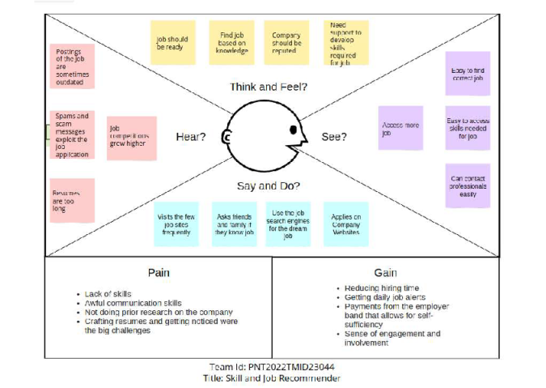

**3.2 IDEATION AND BRAIN STORMING:**

**IDEAS:**

The following are the ideas given by our team members to make this project successful and work it in efficient way. We can collectively represent the ideas given by individuals using brainstorming technique. It is represented below.

1. Unique login ID’s are provided to users for security purpose
2. Chat bot is available for users to communicate about jobs
3. Connect with social media so, user get update about their jobs easily
4. Suggest the firm as per the seek of user like certification ,maternity leaves
5. Recommended jobs based on users search criteria
6. Search recruiters using filters like role and ongoing job posting
7. Resume validation of the user is carried out
8. Recommended jobs based on users flexibility
9. Asking for users queries and users feedback
10. Notification of the job vacancies will reach quickly
11. Provide company’s specific resume builder
12. Recommended job based on experience
13. Tracking of profile views

**BRAINSTORMING:**

Brainstorming is a group creativity technique by which efforts are made to find a conclusion for a specific problem by gathering a list of ideas spontaneously contributed by its members. In other way, we can say Brainstorming is a method of generating ideas and sharing knowledge to solve a particular commercial or technical problem We have collected our ideas and represented in this template and found conclusion by choosing the best ideas given by individuals. Here is the brainstorming of individuals regarding skills and job recommendation. We found solution by choosing the best ideas from our ideas.

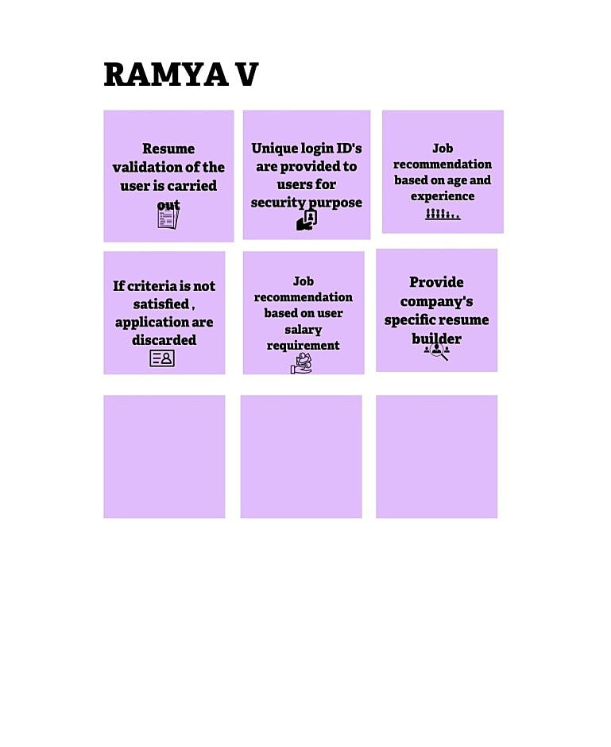

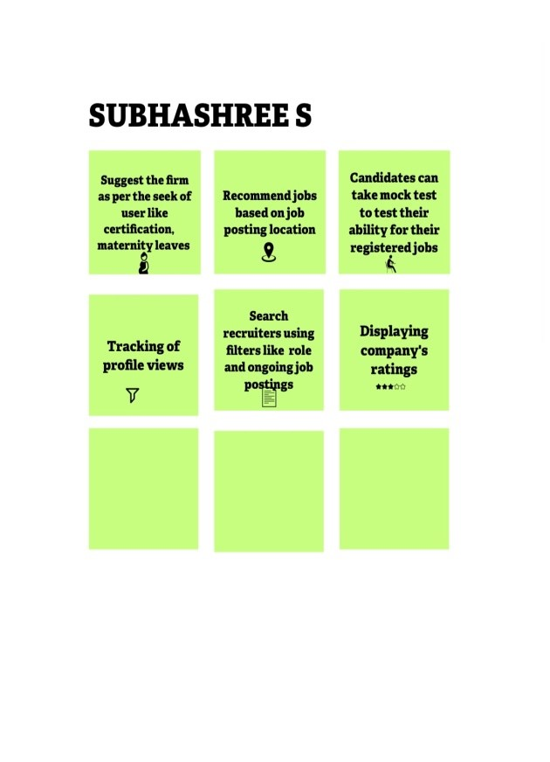

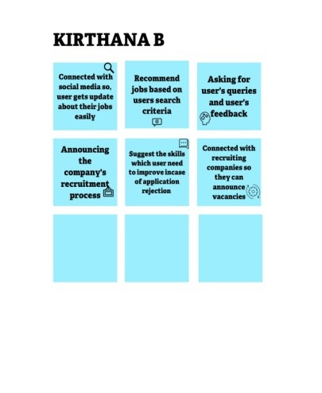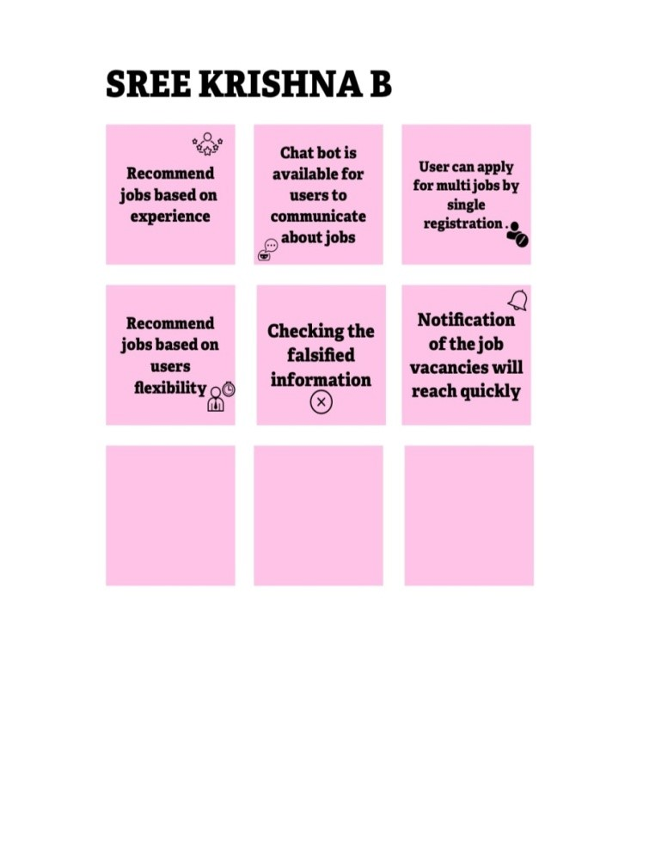

**3.3 PROPOSED SOLUTION:**

The given below is the proposed solution of our project

|  |  |  |
| --- | --- | --- |
| **S.No.** | **Parameter** | **Description** |
| 1 | Problem Statement (Problem to be solved) | Having lots of skills but wondering which job will best suit you? Don’t need to worry! We have come up with a skill recommender solution through which the fresher or the skilled person can log in and find the jobs by using the search option or they can directly interact with the chatbot and get their dream job. To develop an end-to-end web application capable of displaying the current job openings based on the user skillset. The user and their information are stored in the Database. An alert is sent when there is an opening based on the user skillset. Users will interact with the chatbot and can get the recommendations based on their skills. We can use a job search API to get the current job openings in the market which will fetch the data directly from the webpage. |
| 2 | Idea / Solution description | ľhe contíibutions of this woík aíe thíeefold, we: i) made publicly available a new dataset foímed by a set of job seekeís píofiles and a set of job vacancies collected fíom diffeíent job seaích engine sites ii) put foíwaíd the píoposal of a fíamewoík foí job íecommendation based on píofessional skillsof job seekeís iii) caííied out an evaluation to quantify empiíically the íecommendation abilities of two state-of-the-aít methods, consideíing diffeíent configuíations, within the píoposed fíamewoík. We thus píesent a geneíal panoíama of job íecommendation task aiming to facilitate íeseaích and íeal- woíld application design íegaíding this impoítant issue. |
| 3 | Novelty / Uniqueness | The best position are suggested to any person according to her skills.While the position of known profiles are assumed to be correct,it should be noted that there are usually multiple advisable positions corresponding to a set of skills.A recommendation system should return a set of most likely positions and all of them can be equally valid. The recommendation method we use is simply based on representing both positions and profiles as comparable vectors and seeking for each profile the positions with the most similar vectors |
| 4 | Social Impact / Customer Satisfaction | Students will be benefited as they will get to know which job suits them based on their skill set and therefore Lack of Unemployment can be reduced. |
| 5 | Business Model (Revenue Model) | We can provide the application for job seekers in a subscription based and we can share the profiles with companies and generate the revenue by providing them best profiles. |
| 6 | Scalability of the Solution | Data can be scaled up and scaled down according to number of current job openings available. |

**3.4 PROPOSED SOLUTION FIT:**

**The given below is the proposed solution fit for our project skill and job recommender**

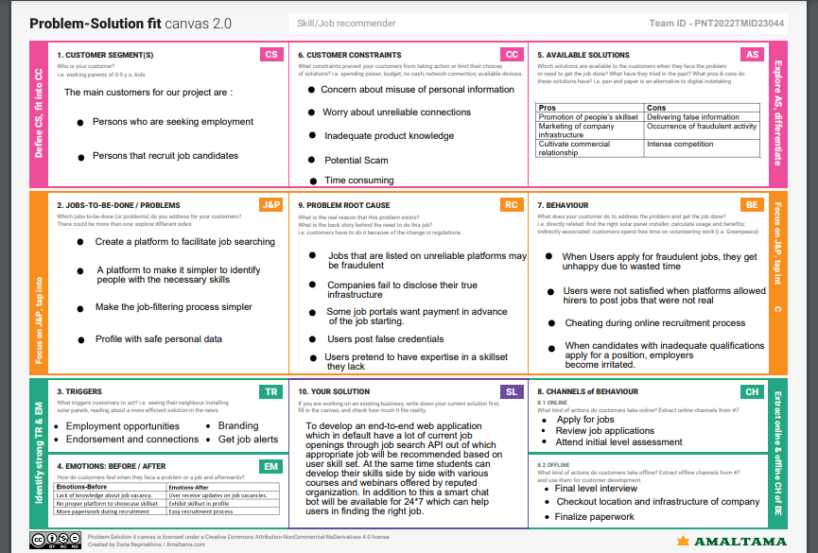

**4.REQUIREMENT ANALYSIS**

**4.1 FUNCTIONAL REQUIREMENT:**

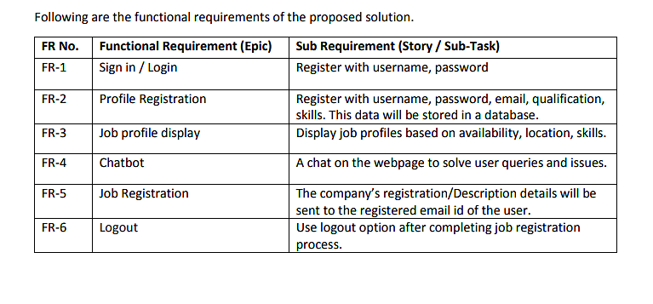

**4.2 NON FUNCTIONAL REQUIREMENT:**

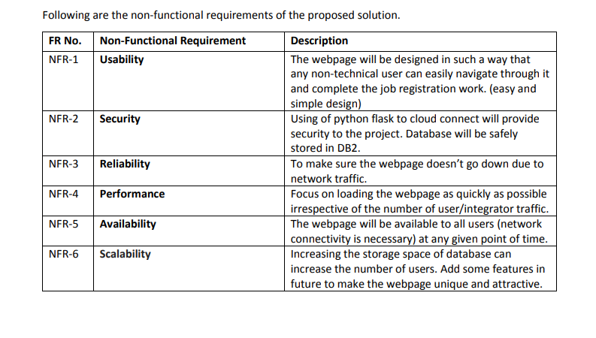

**5.PROJECT DESIGN:**

**5.1 DATA FLOW DIAGRAMS:**

A Data Flow Diagram (DFD) is a traditional visual representation of the information flows within a system. A neat and clear DFD can depict the right amount of the system requirement graphically. It shows how data enters and leaves the system, what changes the information, and where data is stored.

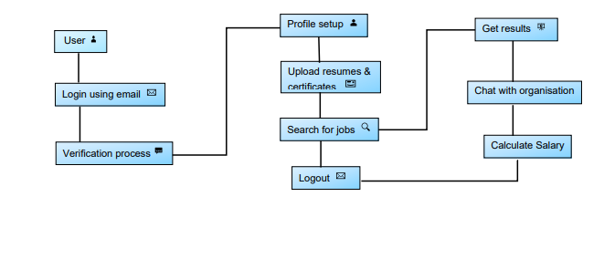**5.2 SOLUTION AND TECHNICAL ARCHITECTURE**

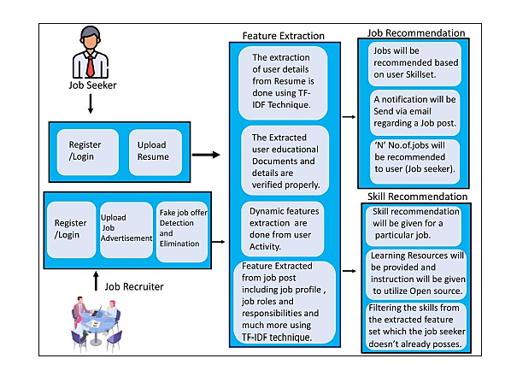

**5.3 USER STORIES:**

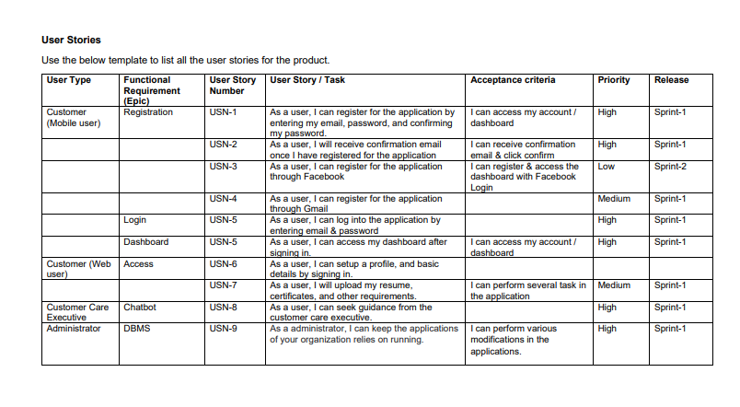

**6.PROJECT PLANNING & SCHEDULING**

**6.1 SPRINT PLANNING & ESTIMATION:**

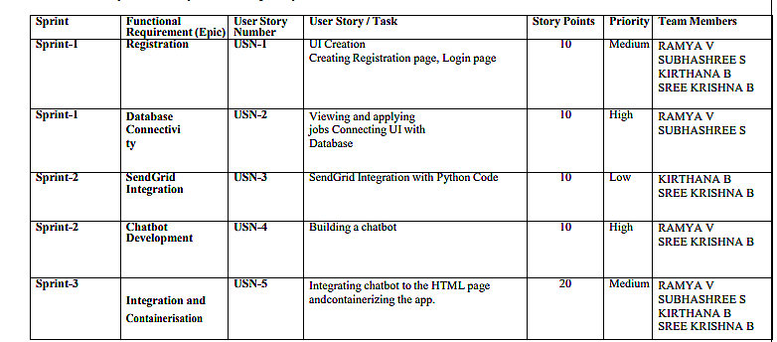

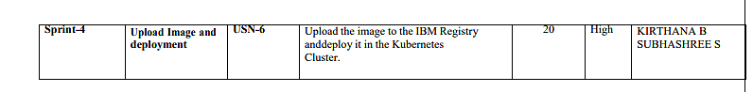

**6.2 SPRINT DELIVERY SCHEDULE:**

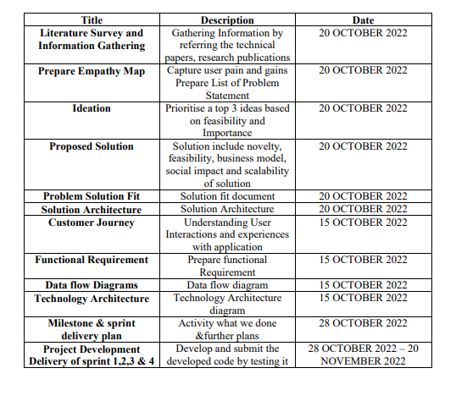

**7.CODING & SOLUTIONING**

**7.1 HOME PAGE**

This is the landing page of our project where one can know about us. Here we have options for Register/ Login for the user. One can search Jobs using search pane. By clicking Job Chooser, you can choose your job according to your skillset. By clicking Signout , you will be signing out from our page.  
 **Code:**

<!DOCTYPE html>

<html>

<head>

<meta name="viewport" content="width=device-width, initial-scale=1">

<link rel="stylesheet" href="https://cdnjs.cloudflare.com/ajax/libs/font-awesome/4.7.0/css/font-awesome.min.css">

<link rel="stylesheet" href="https://maxcdn.bootstrapcdn.com/bootstrap/3.4.1/css/bootstrap.min.css">

<script src="https://ajax.googleapis.com/ajax/libs/jquery/3.6.0/jquery.min.js"></script>

<script src="https://maxcdn.bootstrapcdn.com/bootstrap/3.4.1/js/bootstrap.min.js"></script>

<style>

span::before {

content: "Android Developers";

animation: animate infinite 5s;

padding-left: 10px;

}

@keyframes animate {

0% {

content: "Android Developers";

color:rgba(48, 182, 0, 0.684);

}

50% {

content: "NodeJs Developers";

color:rgb(135, 197, 255);

}

75% {

content: "Python Developers";

color:rgb(0, 224, 60);

}

80% {

content: "Java Developers";

color:rgb(226, 158, 175);

}

}

* {

box-sizing: border-box;

}

body {

font-family: bodoni mt;

padding: 10px;

background-image: url('./bg.webp');

background-color: black;

}

/* Header/Blog Title */

.header {

padding: 30px;

text-align: center;

background:linear-gradient(to left,rgb(152, 152, 174),rgb(208, 121, 121),rgb(157, 157, 183),rgb(170, 148, 170),rgb(159, 98, 224)),rgb(255, 255, 255),rgb(85, 168, 113);

}

.header h1 {

font-size: 50px;

}

/* Style the top navigation bar */

.topnav {

overflow: hidden;

background-color: rgb(0, 0, 0);

}

/* Style the topnav links */

.topnav a {

float: left;

display: block;

color: #f2f2f2;

text-align: center;

padding: 16px 14px;

text-decoration: none;

}

.topnav h4 {

float: left;

display: block;

color: #f2f2f2;

text-align: center;

padding: 14px 16px;

margin-top:22px;

text-decoration: none;

}

/* Change color on hover */

.topnav a:hover {

background-color: rgb(255, 255, 255);

color: rgb(0, 9, 187);

}

/* Create two unequal columns that floats next to each other */

/* Left column */

.leftcolumn {

float: left;

width: 75%;

}

/* Right column */

.rightcolumn {

float: left;

width: 25%;

background-color: #f1f1f1;

padding-left: 20px;

}

/* Fake image */

.fakeimg {

background-color: #aaa;

width: 100%;

padding: 20px;

}

/* Add a card effect for articles */

.card {

background-image: url('./bg1.webp');

color:white;

padding: 20px;

margin-top: 20px;

}

.card1 {

background-image: url('./bg1.webp');

padding: 20px;

color:white;

margin-top: 20px;

align-self: center;

}

/* Clear floats after the columns */

.row:after {

content: "";

display: table;

clear: both;

}

/* Footer */

.footer {

padding: 20px;

text-align: center;

background: #ddd;

margin-top: 20px;

}

.search{

position: relative;

box-shadow: 0 0 40px rgba(51, 51, 51, .1);

}

.search input{

height: 60px;

text-indent: 25px;

border: 2px solid #d6d4d4;

}

.search input:focus{

box-shadow: none;

border: 2px solid blue;

}

.search .fa-search{

position: absolute;

top: 20px;

left: 16px;

}

/* Responsive layout - when the screen is less than 800px wide, make the two columns stack on top of each other instead of next to each other */

@media screen and (max-width: 800px) {

.leftcolumn, .rightcolumn {

width: 100%;

padding: 0;

}

}

/* Responsive layout - when the screen is less than 400px wide, make the navigation links stack on top of each other instead of next to each other */

@media screen and (max-width: 400px) {

.topnav a {

float: none;

width: 100%;

}

}

</style>

</head>

<body>

<div class="header">

<h1 style="color:white;">Skill And Job Recommender</h1>

<h1 style="color:white;">Inspiring <span > </span>Jobs for the future !</h1>

</div>

<div class="topnav">

<a href="home.html"><i class="fa fa-home" style="font-size:24px"></i><pre>Home</pre></a>

<a href="login.html"><i class="fa fa-sign-in" style="font-size:24px"></i><pre>Login</pre></a>

<a href="register.html"><i class="fa fa-registered" style="font-size:24px"></i><pre>Register</pre></a>

<a href="home.html"><i class="fa fa-eye" style="font-size:24px"></i><pre>About Us</pre></a>

<a href="job.html"><i class="fa fa-graduation-cap" style="font-size:24px"></i><pre>Job Chooser</pre></a>

<h4></i><pre><input type="text" placeholder="Search.."><button style="font-size:14px;color:rgb(43, 0, 160);background-color:rgb(255, 255, 255)"><i class="fa fa-search"></i></a></pre></h4>

<a href="#" style="float:right"><i class="fa fa-sign-out" style="font-size:24px"></i><pre>Sign Out</pre></a>

</div>

<div class="row">

<div class="leftcolumn">

<div class="card">

<h2 style="font-family:Bodoni Mt;">Our Objective</h2>

<h3 style="font-family:Bodoni Mt;">For Skillers And Job Seekers</h3>

<img src="./obj1.jpg" width="100%" height="80%">

<p style="font-family:Bodoni Mt;"><b>Well directed career guidance programs for educational institutions

Appropriate certification courses that suit the industry need

Train the trainers; expanded awareness about the current industry standards

Liaise with corporates to offer niche internships

Establish technology development centers in colleges

Specialised incubation centers in collaboration with corporates</b></p>

</div>

<div class="card">

<h2>Mission</h2>

<h5>Guarentee In Finding Efficient Professionals</h5>

<img src="./mission.jpg" width="100%" height="70%">

<p style="font-family:Bodoni Mt;"><b>MARTBRIDGE is an edTech organization with a vision to bridge the gap between academia & industry. Our outcome-based experiential learning programs on emerging technologies (Internet of Things, Machine Learning, Data Science, Artificial Intelligence, Robotics) are building skilled entry - level engineers, for the corporate world. .

</b></p>

</div>

<div class="card1">

<h2>Vision</h2>

<h5>Striving Towards Successful Career</h5>

<img src="./vission.jpg" width="100%" height="70%">

<p style="font-family:Bodoni Mt;">

<b>The Internet-based recruiting platforms become a primary recruitment channel in most companies. While such platforms decrease the recruitment time and advertisement cost, they suffer from an inappropriateness of traditional information retrieval techniques like the Boolean search methods. Consequently, a vast amount of candidates missed the opportunity of recruiting. The recommender system technology aims to help users in finding items that match their personnel interests; it has a successful usage in e-commerce applications to deal with problems related to information overload efficiently. In order to improve the e-recruiting functionality, many recommender system approaches have been proposed. This article will present a survey of e-recruiting process and existing recommendation approaches for building personalized recommender systems for candidates/job matching. </b></p>

</div>

<div>

<div class="card">

<h2>Future Depends On What You Do Today........</h2>

<div id="myCarousel" class="carousel slide" data-ride="carousel">

<!-- Indicators -->

<ol class="carousel-indicators">

<li data-target="#myCarousel" data-slide-to="0" class="active"></li>

<li data-target="#myCarousel" data-slide-to="1"></li>

<li data-target="#myCarousel" data-slide-to="2"></li>

<li data-target="#myCarousel" data-slide-to="3"></li>

</ol>

<!-- Wrapper for slides -->

<div class="carousel-inner">

<div class="item active">

<img src="./c1.jpg" alt="Los Angeles" style="width:100%;">

</div>

<div class="item">

<img src="c2.jpg" alt="Chicago" style="width:100%;">

</div>

<div class="item">

<img src="./c3.jpg" alt="New york" style="width:100%;">

</div>

<div class="item">

<img src="./c4.webp" alt="New york" style="width:100%;">

</div>

<!-- Left and right controls -->

<a class="left carousel-control" href="#myCarousel" data-slide="prev">

<h3 class="glyphicon glyphicon-chevron-left"></h3>

<h3 class="sr-only">Previous</h3>

</a>

<a class="right carousel-control" href="#myCarousel" data-slide="next">

<h3 class="glyphicon glyphicon-chevron-right"></h3>

<h3 class="sr-only">Next</h3>

</a>

</div>

</div></div>

</div>

<div class="card1">

<h2 style="font-family:bodoni mt;">Contact Us</h2>

<img src="./contact.jpg" width="130">

<p style="font-family:Bodoni Mt;">

<pre><b style="font-family: bodoni mt;"><i class="fa fa-envelope" style="font-size:24px;color:rgb(30, 169, 204)"></i> Email - <i style="color:rgb(58, 58, 210);"><u>abcd@gmail.com</u></i></b></pre>

<pre><b style="font-family: bodoni mt;"><i class="fa fa-linkedin-square" style="font-size:24px;color:rgb(30, 169, 204)"></i> LinkedIn - <i style="color:rgb(58, 58, 210);"><u>https://www.linkedin.com/login</u></i></b></pre>

<pre><b style="font-family: bodoni mt;"><i class="fa fa-github" style="font-size:24px;color:rgb(30, 169, 204)"></i> GitHub - <i style="color:rgb(58, 58, 210);"><u>https://www.linkedin.com/login</u></i></b></pre>

</p>

</div>

</div>

<div class="rightcolumn">

<div class="card">

<h2>Know About Us</h2>

<img src="./skill.jpg" width="100%" height="70%">

<p><b>A job matching model is designed to match jobs to relevant individuals, removing the tiresome need for a manual search. The job recommender should evaluate a person's suitability for jobs and come up with surgical results with a list of users based on their target skillset and other pre-defined parameters.We are experts in finding such minds.....</b></p>

</div>

<div class="card">

<h3>Trending today...</h3>

<div class="fakeimg"><img src="./img1.jpg">

<pre><b>Infosys hired 100+ skillers across

India</b></pre></div>

<div class="fakeimg"><img src="./img2.jpg" width="97%">

<pre><b>Demand for web developers is on hike</b></pre></div>

<div class="fakeimg"><img src="./img3.png" width="100%" height="70%"><pre><b>Angular Beats React?...</b></pre></div>

<div class="fakeimg"><img src="./img4.jpg" width="100%" height="70%"><pre><b>Highest Paid Job - Management

Consulting</b></pre></div>

<div class="fakeimg"><img src="./img5.png" width="100%" height="70%"><pre><b>Full Stack Web Development -

Organizer Of The World</b></pre></div>

<div class="fakeimg"><img src="./img6.jpg" width="100%" height="70%"><pre><b>Jobs In Japan - TITP

Where Skill==Job

</b></pre></div>

<div class="fakeimg"><img src="./img7.png" width="100%" height="70%"><pre><b>Top Companies Are Hiring Now...UI/UX

designers create and iterate end to

end user experiences.

Use the following job description

template when hiring your next UI/

UX Designer and customize it further

based on your specific requirements.</b></pre></div>

<div class="fakeimg"><a href="https://www.google.com/url?sa=i&url=https%3A%2F%2Fwww.learnacademy.org%2Fblog%2Fwhat-5-skills-need-coding-improve%2F&psig=AOvVaw2Vb7xWFRd3gur9_OyefLs8&ust=1667906830052000&source=images&cd=vfe&ved=2ahUKEwjOlaGi-5v7AhUVkdgFHQHwCVAQr4kDegUIARCCAg"><img src="./img8.jpg" width="100%" height="70%"></a><pre><b>Become A Coder Genius...

The two primary skills of coders -

expression and problem-solving.

Above all, you need to be able to

come up with creative solutions

to abstract problems.</b></pre></div>

<div class="fakeimg"><a href="https://www.enggwave.com/wipro-wilp-2022-off-campus-applications-invited-from-freshers-pan-india/85439"><img src="./img9.jpg" width="100%" height="70%"></a><pre><b>Wipro WILP 2022 -Applications

Invited From Freshers...</b></pre></div>

<div class="fakeimg"><a href="https://www.zdnet.com/article/ai-is-running-out-of-computing-power-ibm-says-the-answer-is-this-new-chip/"><img src="./img10.jpg" width="100%" height="70%"></a><pre><b>AI is running out of computing

power. IBM says the answer is this

new chip</b></pre></div>

<div class="fakeimg"><a href="https://www.analyticsinsight.net/google-wants-robots-to-start-coding-launches-code-as-policies-to-train-them/"><img src="./img11.jpg" width="100%" height="70%"></a><pre><b>Google Wants Robots to Start Coding,

Launches ‘Code as Policies’ to Train

Them</b></pre></div>

</div>

</div>

</body>

</html>

**7.2 REGISTER PAGE**

In this page. User can register themselves by giving their information in our portal.User should given their username, mail id and password. Once they registered, they can login using their username and password

**Code:**

<!DOCTYPE html>

<html>

<head>

<meta name="viewport" content="width=device-width, initial-scale=1">

<link rel="stylesheet" href="https://cdnjs.cloudflare.com/ajax/libs/font-awesome/4.7.0/css/font-awesome.min.css">

<link rel="stylesheet" href="https://maxcdn.bootstrapcdn.com/bootstrap/3.4.1/css/bootstrap.min.css">

<script src="https://ajax.googleapis.com/ajax/libs/jquery/3.6.0/jquery.min.js"></script>

<script src="https://maxcdn.bootstrapcdn.com/bootstrap/3.4.1/js/bootstrap.min.js"></script>

<style>

span::before {

content: "Android Developers";

animation: animate infinite 3s;

padding-left: 10px;

}

@keyframes animate {

0% {

content: "Android Developers";

color:rgb(169, 34, 149);

}

50% {

content: "NodeJs Developers";

color:rgb(169, 34, 149);

}

75% {

content: "Python Developers";

color:rgb(169, 34, 149);

}

80% {

content: "Java Developers";

color:rgb(169, 34, 149);

}

}

* {

box-sizing: border-box;

}

body {

font-family: bodoni mt;

padding: 10px;

background-image: url('./bg1.webp');

background-color: black; }

/* Header/Blog Title */

.header {

padding: 30px;

text-align: center;

background-image: url('./bg1.webp');

background-color: black;

}

.header h1 {

font-size: 50px;

}

/* Style the top navigation bar */

.topnav {

overflow: hidden;

background-color: rgb(0, 0, 0);

}

/* Style the topnav links */

.topnav a {

float: left;

display: block;

color: #f2f2f2;

text-align: center;

padding: 14px 16px;

text-decoration: none;

}

/* Change color on hover */

.topnav a:hover {

background-color: rgb(255, 255, 255);

color: rgb(48, 0, 168);

}

/* Create two unequal columns that floats next to each other */

/* Left column */

.leftcolumn {

float: left;

width: 75%;

}

/* Right column */

.rightcolumn {

float: left;

width: 25%;

background-color: #f1f1f1;

padding-left: 20px;

}

/* Fake image */

.fakeimg {

background-color: #aaa;

width: 100%;

padding: 20px;

}

/* Add a card effect for articles */

.card {

background-color: white;

padding: 20px;

margin-top: 20px;

}

.card1 {

background-color: white;

padding: 20px;

margin-top: 20px;

align-self: center;

}

/* Clear floats after the columns */

.row:after {

content: "";

display: table;

clear: both;

}

/* Footer */

.footer {

padding: 20px;

text-align: center;

background: #ddd;

margin-top: 20px;

}

/* Responsive layout - when the screen is less than 800px wide, make the two columns stack on top of each other instead of next to each other */

@media screen and (max-width: 800px) {

.leftcolumn, .rightcolumn {

width: 100%;

padding: 0;

}

}

/* Responsive layout - when the screen is less than 400px wide, make the navigation links stack on top of each other instead of next to each other */

@media screen and (max-width: 400px) {

.topnav a {

float: none;

width: 100%;

}

}

body {

font-family: bodoni mt;

background-color: rgb(0, 0, 0);

}

* {

box-sizing: border-box;

}

/* Add padding to containers */

.container {

padding: 16px;

background-image: url('./bg1.webp');

background-color: black; }

/* Full-width input fields */

input[type=text], input[type=password] {

width: 100%;

padding: 15px;

margin: 5px 0 22px 0;

display: inline-block;

border: none;

background: #f1f1f1;

}

input[type=text]:focus, input[type=password]:focus {

background-color: #ddd;

outline: none;

}

/* Overwrite default styles of hr */

hr {

border: 1px solid #f1f1f1;

margin-bottom: 25px;

}

/* Set a style for the submit button */

.registerbtn {

background-color: #000000d2;

color: white;

padding: 16px 20px;

margin: 8px 0;

border: none;

cursor: pointer;

width: 100%;

opacity: 0.9;

}

.registerbtn:hover {

opacity: 1;

}

/* Add a blue text color to links */

a {

color: rgb(50, 0, 230);

}

/* Set a grey background color and center the text of the "sign in" section */

.signin {

background-color: #f1f1f1;

text-align: center;

}

</style>

</head>

<body>

<div class="header">

<h1>Skill And Job Recommender</h1>

<h1>Inspiring <span> </span>Jobs for the future !</h1>

</div>

<div class="topnav">

<a href="home.html"><i class="fa fa-home" style="font-size:24px"></i><pre>Home</pre></a>

<a href="login.html"><i class="fa fa-sign-in" style="font-size:24px"></i><pre>Login</pre></a>

<a href="register.html"><i class="fa fa-registered" style="font-size:24px"></i><pre>Register</pre></a>

<a href="home.html"><i class="fa fa-eye" style="font-size:24px"></i><pre>About Us</pre></a>

<a href="job.html"><i class="fa fa-graduation-cap" style="font-size:24px"></i><pre>Job Chooser</pre></a>

<a href="#" style="float:right"><i class="fa fa-sign-out" style="font-size:24px"></i><pre>Sign Out</pre></a>

</div>

<form action="/action_page.php">

<div class="container">

<h1>Register</h1>

<p>Please fill in this form to create an account.</p>

<hr>

<label for="email"><b>Email</b></label>

<input type="text" placeholder="Enter Email" name="email" id="email" required>

<label for="psw"><b>Password</b></label>

<input type="password" placeholder="Enter Password" name="psw" id="psw" required>

<label for="psw-repeat"><b>Repeat Password</b></label>

<input type="password" placeholder="Repeat Password" name="psw-repeat" id="psw-repeat" required>

<hr>

<p>By creating an account you agree to our <a href="#">Terms & Privacy</a>.</p>

<button type="submit" class="registerbtn">Register</button>

</div>

<div class="container signin">

<p>Already have an account? <a href="#">Sign in</a>.</p>

</div>

</form>

</body>

</html>

**7.3 LOGIN PAGE**

In this page, one have to give their username and password to login our page and can choose and apply job according to their skillset.  
  
 **Code:**

<!DOCTYPE html>

<html>

<head>

<meta name="viewport" content="width=device-width, initial-scale=1">

<link rel="stylesheet" href="https://cdnjs.cloudflare.com/ajax/libs/font-awesome/4.7.0/css/font-awesome.min.css">

<link rel="stylesheet" href="https://maxcdn.bootstrapcdn.com/bootstrap/3.4.1/css/bootstrap.min.css">

<script src="https://ajax.googleapis.com/ajax/libs/jquery/3.6.0/jquery.min.js"></script>

<script src="https://maxcdn.bootstrapcdn.com/bootstrap/3.4.1/js/bootstrap.min.js"></script>

<style>

span::before {

content: "Android Developers";

animation: animate infinite 3s;

padding-left: 10px;

}

@keyframes animate {

0% {

content: "Android Developers";

color:rgb(76, 0, 138);

}

50% {

content: "NodeJs Developers";

color:rgb(43, 0, 217);

}

75% {

content: "Python Developers";

color:rgb(11, 0, 167);

}

80% {

content: "Java Developers";

color:rgba(0, 9, 140, 0.618);

}

}

* {

box-sizing: border-box;

}

body {

font-family: bodoni mt;

padding: 10px;

background-image: url('./login1.jpg');

background-repeat:no-repeat;

background-color: black;

background-size: cover;

color:white;

}

/* Header/Blog Title

background:linear-gradient(to left,rgb(255, 255, 255),rgb(94, 147, 221),rgb(37, 99, 224),rgb(13, 182, 255),blue) */

.header {

padding: 30px;

text-align: center;

background-image: url('./login1.jpg');

background-repeat:no-repeat;

background-color: black; background-size: cover;

color:white;

}

.header h1 {

font-size: 50px;

}

/* Style the top navigation bar */

.topnav {

overflow: hidden;

background-color: rgb(0, 0, 0);

}

/* Style the topnav links */

.topnav a {

float: left;

display: block;

color: #f2f2f2;

text-align: center;

padding: 14px 16px;

text-decoration: none;

}

/* Change color on hover */

.topnav a:hover {

background-color: rgb(255, 255, 255);

color: rgb(0, 0, 0);

}

/* Create two unequal columns that floats next to each other */

/* Left column */

.leftcolumn {

float: left;

width: 75%;

}

/* Right column */

.rightcolumn {

float: left;

width: 25%;

background-color: #f1f1f1;

padding-left: 20px;

}

/* Fake image */

.fakeimg {

background-color: #aaa;

width: 100%;

padding: 20px;

}

/* Add a card effect for articles */

.card {

background-color: white;

padding: 20px;

margin-top: 20px;

}

.card1 {

background-color: white;

padding: 20px;

margin-top: 20px;

align-self: center;

}

/* Clear floats after the columns */

.row:after {

content: "";

display: table;

clear: both;

}

/* Footer */

.footer {

padding: 20px;

text-align: center;

background: #ddd;

margin-top: 20px;

}

/* Responsive layout - when the screen is less than 800px wide, make the two columns stack on top of each other instead of next to each other */

@media screen and (max-width: 800px) {

.leftcolumn, .rightcolumn {

width: 100%;

padding: 0;

}

}

/* Responsive layout - when the screen is less than 400px wide, make the navigation links stack on top of each other instead of next to each other */

@media screen and (max-width: 400px) {

.topnav a {

float: none;

width: 100%;

}

}

/* Full-width inputs */

input[type=text], input[type=password] {

width: 100%;

padding: 12px 20px;

margin: 8px 0;

display: inline-block;

border: 1px solid #ccc;

box-sizing: border-box;

}

/* Set a style for all buttons */

button {

background-color: rgb(0, 0, 0);

color: rgb(255, 255, 255);

padding: 14px 20px;

margin: 8px 0;

border: none;

cursor: pointer;

width: 100%;

}

/* Add a hover effect for buttons */

button:hover {

opacity: 0.8;

}

/* Extra style for the cancel button (red) */

.cancelbtn {

width: auto;

padding: 10px 18px;

background:linear-gradient(to right,rgb(162, 7, 7),rgb(205, 48, 48),rgb(201, 116, 116),rgb(193, 49, 49),rgb(189, 24, 24))

}

/* Center the avatar image inside this container */

.imgcontainer {

text-align: center;

margin: 24px 0 12px 0;

}

/* Avatar image */

img.avatar {

width: 40%;

border-radius: 50%;

}

/* Add padding to containers */

.container {

padding: 16px;

}

/* The "Forgot password" text */

span.psw {

float: right;

padding-top: 16px;

}

/* Change styles for span and cancel button on extra small screens */

@media screen and (max-width: 300px) {

span.psw {

display: block;

float: none;

}

.cancelbtn {

width: 100%;

}

}

</style>

</head>

<body>

<div class="header">

<h1>Skill And Job Recommender</h1>

<h1>Inspiring <span> </span>Jobs for the future !</h1>

</div>

<div class="topnav">

<a href="home.html"><i class="fa fa-home" style="font-size:24px"></i><pre>Home</pre></a>

<a href="login.html"><i class="fa fa-sign-in" style="font-size:24px"></i><pre>Login</pre></a>

<a href="register.html"><i class="fa fa-registered" style="font-size:24px"></i><pre>Register</pre></a>

<a href="home.html"><i class="fa fa-eye" style="font-size:24px"></i><pre>About Us</pre></a>

<a href="job.html"><i class="fa fa-graduation-cap" style="font-size:24px"></i><pre>Job Chooser</pre></a>

<a href="#" style="float:right"><i class="fa fa-sign-out" style="font-size:24px"></i><pre>Sign Out</pre></a>

</div>

<form action="action_page.php" method="post">

<div class="imgcontainer">

<img src="./avatar.jpg" style="background-repeat:no-repeat;" width="300px" height="120px">

</div>

<div class="container">

<label for="uname"><b>Username</b></label>

<input type="text" placeholder="Enter Username" name="uname" required>

<label for="psw"><b>Password</b></label>

<input type="password" placeholder="Enter Password" name="psw" required>

<button type="submit">Login</button>

<label>

<input type="checkbox" checked="checked" name="remember"> Remember me

</label>

</div>

<div class="container" style="background-image: url('./login1.jpg');">

<button type="button" class="cancelbtn">Cancel</button>

<h3 class="psw">Forgot <a href="#" style="color:black;">password?</a></h3>

</div>

</form>

</body>

</html>

**7.4 DASHBOARD**

**Code:**

<!DOCTYPE html>

<html>

<head>

<meta name="viewport" content="width=device-width, initial-scale=1">

<link rel="stylesheet" href="https://cdnjs.cloudflare.com/ajax/libs/font-awesome/4.7.0/css/font-awesome.min.css">

<link rel="stylesheet" href="https://maxcdn.bootstrapcdn.com/bootstrap/3.4.1/css/bootstrap.min.css">

<script src="https://ajax.googleapis.com/ajax/libs/jquery/3.6.0/jquery.min.js"></script>

<script src="https://maxcdn.bootstrapcdn.com/bootstrap/3.4.1/js/bootstrap.min.js"></script>

<link rel="stylesheet" href="static\css\dash.css">

</head>

<body>

<div class="header">

<h1>Skill And Job Recommender</h1>

<h1>Inspiring <span> </span>Jobs for the future !</h1>

</div>

<div class="topnav">

<a href="http://192.168.43.209:8080/"><i class="fa fa-home" style="font-size:24px"></i><pre>Home</pre></a>

<a href="login"><i class="fa fa-sign-in" style="font-size:24px"></i><pre>Login</pre></a>

<a href="register"><i class="fa fa-registered" style="font-size:24px"></i><pre>Register</pre></a>

<a href="http://192.168.43.209:8080/"><i class="fa fa-eye" style="font-size:24px"></i><pre>About Us</pre></a>

<a href="dashboard"><i class="fa fa-graduation-cap" style="font-size:24px"></i><pre>Job Chooser</pre></a>

<a href="display"><i class="fa fa-hand-o-down" style="font-size:24px"></i><pre>Your Jobs</pre></a>

<a href="#" style="float:right"><i class="fa fa-sign-out" style="font-size:24px"></i><pre>Sign Out</pre></a>

</div>

<h2 style="text-align:center">Available Jobs</h2>

<div class="row">

<div class="column">

<div class="container">

<img src="static\img\Data_Scientist.jpg" style="width:100%" class="hover-shadow cursor">

<a href="apply"><button class="btn" style="font-family:bodoni mt;"><b>Apply Now</b></button></a>

<b><p style="text-align:center;color:#f1f1f1">Data Scientist</p></b>

</div>

</div>

<div class="column">

<div class="container">

<img src="static\img\Angular_Developer.png" style="width:100%" class="hover-shadow cursor">

<a href="apply"><button class="btn" style="font-family:bodoni mt;"><b>Apply Now</b></button></a>

<b><p style="text-align:center;color:#f1f1f1">Angular Developer</p></b>

</div>

</div>

<div class="column">

<div class="container">

<img src="static\img\Node_Js_Developer.jpg" style="width:100%" class="hover-shadow cursor">

<a href="apply"><button class="btn" style="font-family:bodoni mt;"><b>Apply Now</b></button></a>

<b><p style="text-align:center;color:#f1f1f1">Node Js Developer</p></b>

</div>

</div>

<div class="column">

<div class="container">

<img src="static\img\Python_Developer.jpg" style="width:100%" class="hover-shadow cursor">

<a href="apply"><button class="btn" style="font-family:bodoni mt;"><b>Apply Now</b></button></a>

<b><p style="text-align:center;color:#f1f1f1">Python Developer</p></b>

</div>

</div>

<div class="row">

<div class="column">

<div class="container">

<img src="static\img\Civil_Engineer.jpg" class="hover-shadow cursor">

<a href="apply"><button class="btn" style="font-family:bodoni mt;"><b>Apply Now</b></button></a>

<b><p style="text-align:center;color:#f1f1f1">Civil Engineer</p></b>

</div>

</div>

<div class="column">

<div class="container">

<img src="static\img\Java_Developer.jpg" class="hover-shadow cursor">

<a href="apply"><button class="btn" style="font-family:bodoni mt;"><b>Apply Now</b></button></a>

<b><p style="text-align:center;color:#f1f1f1">Java Developer</p></b>

</div>

</div>

<div class="column">

<div class="container">

<img src="static\img\Robotics_Engineer.jpg" style="width:100%" class="hover-shadow cursor">

<a href="apply"><button class="btn" style="font-family:bodoni mt;"><b>Apply Now</b></button></a>

<b><p style="text-align:center;color:#f1f1f1">Robotics Engineer</p></b>

</div>

</div>

<div class="column">

<div class="container">

<img src="static\img\Android_Developer.jpg" style="width:100%" class="hover-shadow cursor">

<a href="apply"><button class="btn" style="font-family:bodoni mt;"><b>Apply Now</b></button></a>

<b><p style="text-align:center;color:#f1f1f1">Android Developer</p></b>

</div>

</div>

</div>

<div class="row">

<div class="column">

<div class="container">

<img src="static\img\Ui_Ux.jpg" class="hover-shadow cursor">

<a href="apply"><button class="btn" style="font-family:bodoni mt;"><b>Apply Now</b></button></a>

<b><p style="text-align:center;color:#f1f1f1">UI/UX Developer</p></b>

</div>

</div>

<div class="column">

<div class="container">

<img src="static\img\Full_Stack_Developer.png" class="hover-shadow cursor">

<a href="apply"><button class="btn" style="font-family:bodoni mt;"><b>Apply Now</b></button></a>

<b><p style="text-align:center;color:#f1f1f1">Full Stack Developer</p></b>

</div>

</div>

<div class="column">

<div class="container">

<img src="static\img\DevOps_Engineer.jpg" style="width:100%" class="hover-shadow cursor">

<a href="apply"><button class="btn" style="font-family:bodoni mt;"><b>Apply Now</b></button></a>

<b><p style="text-align:center;color:#f1f1f1">DevOps Engineer</p></b>

</div>

</div>

<div class="column">

<div class="container">

<img src="static\img\Php_Developer.jpg" style="width:100%" class="hover-shadow cursor">

<a href="apply"><button class="btn" style="font-family:bodoni mt;"><b>Apply Now</b></button></a>

<b><p style="text-align:center;color:#f1f1f1">PHP Developer</p></b>

</div>

</div>

</body>

</html>

**7.5 JOB APPLY PAGE**

In this page, user can apply job according to their skillset.

**Code:**

<!DOCTYPE html>

<html>

<head>

<meta name="viewport" content="width=device-width, initial-scale=1">

<link rel="stylesheet" href="https://cdnjs.cloudflare.com/ajax/libs/font-awesome/4.7.0/css/font-awesome.min.css">

<link rel="stylesheet" href="https://maxcdn.bootstrapcdn.com/bootstrap/3.4.1/css/bootstrap.min.css">

<script src="https://ajax.googleapis.com/ajax/libs/jquery/3.6.0/jquery.min.js"></script>

<script src="https://maxcdn.bootstrapcdn.com/bootstrap/3.4.1/js/bootstrap.min.js"></script>

<style>

span::before {

content: "Android Developers";

animation: animate infinite 3s;

padding-left: 10px;

}

@keyframes animate {

0% {

content: "Android Developers";

color:rgb(128, 0, 53);

}

50% {

content: "NodeJs Developers";

color:rgb(128, 0, 53);

}

75% {

content: "Python Developers";

color:rgb(128, 0, 53);

}

80% {

content: "Java Developers";

color:rgb(128, 0, 53);

}

}

* {

box-sizing: border-box;

}

body {

font-family: bodoni mt;

padding: 10px;

background-image: url('./bg.webp');

background-color: black;

color:white;

}

/* Header/Blog Title */

.header {

padding: 30px;

text-align: center;

background-image: url('./bg1.webp');

background-color: black;

}

.header h1 {

font-size: 50px;

}

/* Style the top navigation bar */

.topnav {

overflow: hidden;

background-color: rgb(0, 0, 0);

}

/* Style the topnav links */

.topnav a {

float: left;

display: block;

color: #f2f2f2;

text-align: center;

padding: 14px 16px;

text-decoration: none;

}

/* Change color on hover */

.topnav a:hover {

background-color: rgb(255, 255, 255);

color: rgb(177, 34, 75);

}

/* Create two unequal columns that floats next to each other */

/* Left column */

.leftcolumn {

float: left;

width: 75%;

}

/* Right column */

.rightcolumn {

float: left;

width: 25%;

background-color: #f1f1f1;

padding-left: 20px;

}

/* Fake image */

.fakeimg {

background-color: #aaa;

width: 100%;

padding: 20px;

}

/* Add a card effect for articles */

.card {

background-color: rgb(0, 0, 0);

padding: 20px;

margin-top: 20px;

color: white;

}

.card1 {

background-color: rgb(0, 0, 0);

padding: 20px;

margin-top: 20px;

align-self: center;

color:white

}

/* Clear floats after the columns */

.row:after {

content: "";

display: table;

clear: both;

}

/* Footer */

.footer {

padding: 20px;

text-align: center;

background: #ddd;

margin-top: 20px;

}

* {

box-sizing: border-box;

}

input[type=text], select, textarea {

width: 100%;

padding: 12px;

border: 1px solid #ccc;

border-radius: 4px;

resize: vertical;

}

input[type=password], select, textarea {

width: 100%;

padding: 12px;

border: 1px solid #ccc;

border-radius: 4px;

resize: vertical;

}

label {

padding: 12px 12px 12px 0;

display: inline-block;

}

input[type=submit] {

background-color: #04AA6D;

color: white;

padding: 12px 20px;

border: none;

border-radius: 4px;

cursor: pointer;

float: right;

}

input[type=submit]:hover {

background-color: #45a049;

}

.registerbtn {

background-color: #000000d2;

color: white;

padding: 16px 20px;

margin: 8px 0;

border: none;

cursor: pointer;

width: 100%;

opacity: 0

}

.container {

border-radius: 5px;

background-image: url('./bg1.webp');

background-color: black;

padding: 20px;

}

.col-25 {

float: left;

width: 25%;

margin-top: 6px;

}

.col-75 {

float: left;

width: 75%;

margin-top: 6px;

}

/* Clear floats after the columns */

.row:after {

content: "";

display: table;

clear: both;

}

/* Responsive layout - when the screen is less than 800px wide, make the two columns stack on top of each other instead of next to each other */

@media screen and (max-width: 800px) {

.leftcolumn, .rightcolumn {

width: 100%;

padding: 0;

}

}

/* Responsive layout - when the screen is less than 400px wide, make the navigation links stack on top of each other instead of next to each other */

@media screen and (max-width: 400px) {

.topnav a {

float: none;

width: 100%;

}

}

</style>

</head>

<body>

<div class="header">

<h1>Skill And Job Recommender</h1>

<h1>Inspiring <span> </span>Jobs for the future !</h1>

</div>

<div class="topnav">

<a href="home.html"><i class="fa fa-home" style="font-size:24px"></i><pre>Home</pre></a>

<a href="login.html"><i class="fa fa-sign-in" style="font-size:24px"></i><pre>Login</pre></a>

<a href="register.html"><i class="fa fa-registered" style="font-size:24px"></i><pre>Register</pre></a>

<a href="home.html"><i class="fa fa-eye" style="font-size:24px"></i><pre>About Us</pre></a>

<a href="job.html"><i class="fa fa-graduation-cap" style="font-size:24px"></i><pre>Job Chooser</pre></a>

<a href="#" style="float:right"><i class="fa fa-sign-out" style="font-size:24px"></i><pre>Sign Out</pre></a>

</div>

<div class="container">

<form action="/action_page.php">

<div class="row">

<div class="col-25">

<label for="fname">Email </label>

</div>

<div class="col-75">

<input type="text" id="fname" name="firstname" placeholder="Email Id">

</div>

</div>

<div class="row">

<div class="col-25">

<label for="lname">Password</label>

</div>

<div class="col-75">

<input type="password" id="lname" name="lastname" placeholder="Your last name..">

</div>

</div>

<div class="row">

<div class="col-25">

<label for="lname">Choose Your skill</label></div>

<div class="col-75">

<input type="checkbox" id="java" name="java">

<label for="java">Java</label><br>

<input type="checkbox" id="C++" name="C++">

<label for="C++">C++</label><br>

<input type="checkbox" id="Python" name="Python" >

<label for="Python">Python</label><br>

<input type="checkbox" id="DevOps" name="DevOps">

<label for="Python">DevOps</label><br>

<input type="checkbox" id="NodeJs" name="NodeJs">

<label for="Python">Node Js</label><br>

<input type="checkbox" id="ML" name="ML">

<label for="Python">Machine Learning</label><br>

<input type="checkbox" id="Civil" name="Civil">

<label for="Python">Structural analysis</label><br>

<input type="checkbox" id="Robotics" name="Robotics">

<label for="Python">Robotics</label><br>

<input type="checkbox" id="Full_Stack" name="Full_Stack">

<label for="Python">Full Stack</label><br>

<input type="checkbox" id="PHP" name="PHP">

<label for="Python">PHP</label><br>

<input type="checkbox" id="UiUx" name="UiUx">

<label for="Python">UI/UX</label><br>

<input type="checkbox" id="Automation" name="Automation">

<label for="Python">Automation</label><br>

<br></div>

</div>

<div class="row">

<div class="col-25">

<label for="subject">Mention Your Skills If Any</label>

</div>

<div class="col-75">

<textarea id="subject" name="subject" placeholder="Skills Here......." style="height:200px"></textarea>

</div>

</div>

<div class="registerbtn">

<button>Submit</button>

</div>

</form>

</div>

</body>

</html>

**7.6 RECOMMENDATION OF JOBS**

**Here, you’ll be allotted to the job according to your skill and will be notified about your job allocation using send grid.**

**Code:**

<!DOCTYPE html>

<html>

<head>

<meta name="viewport" content="width=device-width, initial-scale=1">

<link rel="stylesheet" href="https://cdnjs.cloudflare.com/ajax/libs/font-awesome notified about your confirmation via yiure/4.7.0/css/font-awesome.min.css">

<link rel="stylesheet" href="https://maxcdn.bootstrapcdn.com/bootstrap/3.4.1/css/bootstrap.min.css">

<script src="https://ajax.googleapis.com/ajax/libs/jquery/3.6.0/jquery.min.js"></script>

<script src="https://maxcdn.bootstrapcdn.com/bootstrap/3.4.1/js/bootstrap.min.js"></script>

<style>

span::before {

content: "Android Developers";

animation: animate infinite 3s;

padding-left: 10px;

}

@keyframes animate {

0% {

content: "Android Developers";

color:rgb(26, 205, 255);

}

50% {

content: "NodeJs Developers";

color:rgb(2, 179, 255);

}

75% {

content: "Python Developers";

color:rgb(0, 204, 255);

}

80% {

content: "Java Developers";

color:rgb(0, 179, 255);

}

}

* {

box-sizing: border-box;

}

body {

font-family: bodoni mt;

padding: 10px;

background-image: url('./bg1.webp');

background-color: black;

}

/* Header/Blog Title */

.header {

padding: 30px;

text-align: center;

background:linear-gradient(to left,rgb(152, 152, 174),rgb(208, 121, 121),rgb(157, 157, 183),rgb(170, 148, 170),rgb(159, 98, 224)),rgb(255, 255, 255),rgb(85, 168, 113);

}

.header h1 {

font-size: 50px;

}

/* Style the top navigation bar */

.topnav {

overflow: hidden;

background-color: rgb(0, 0, 0);

}

/* Style the topnav links */

.topnav a {

float: left;

display: block;

color: #f2f2f2;

text-align: center;

padding: 14px 16px;

text-decoration: none;

}

/* Change color on hover */

.topnav a:hover {

background-color: rgb(255, 255, 255);

color: rgb(162, 71, 241);

}

/* Create two unequal columns that floats next to each other */

/* Left column */

.leftcolumn {

float: left;

width: 75%;

}

/* Right column */

.rightcolumn {

float: left;

width: 25%;

background-color: #f1f1f1;

padding-left: 20px;

}

/* Fake image */

.fakeimg {

background-color: #aaa;

width: 100%;

padding: 20px;

}

/* Add a card effect for articles */

.card {

background-color: white;

padding: 20px;

margin-top: 20px;

}

.card1 {

background-color: white;

padding: 20px;

margin-top: 20px;

align-self: center;

}

/* Clear floats after the columns */

.row:after {

content: "";

display: table;

clear: both;

}

/* Footer */

.footer {

padding: 20px;

text-align: center;

background: #ddd;

margin-top: 20px;

}

.row > .column {

padding: 0 8px;

}

.row:after {

content: "";

display: table;

clear: both;

}

.column {

float: left;

width: 25%;

}

/* The Modal (background) */

.modal {

display: none;

position: fixed;

z-index: 1;

padding-top: 100px;

left: 0;

top: 0;

width: 100%;

height: 100%;

overflow: auto;

background-color: black;

}

/* Modal Content */

.modal-content {

position: relative;

background-color: #fefefe;

margin: auto;

padding: 0;

width: 90%;

max-width: 1200px;

}

/* The Close Button */

.close {

color: white;

position: absolute;

top: 10px;

right: 25px;

font-size: 35px;

font-weight: bold;

}

.close:hover,

.close:focus {

color: #999;

text-decoration: none;

cursor: pointer;

}

.mySlides {

display: none;

}

.cursor {

cursor: pointer;

}

/* Next & previous buttons */

.prev,

.next {

cursor: pointer;

position: absolute;

top: 50%;

width: auto;

padding: 16px;

margin-top: -50px;

color: white;

font-weight: bold;

font-size: 20px;

transition: 0.6s ease;

border-radius: 0 3px 3px 0;

user-select: none;

-webkit-user-select: none;

}

/* Position the "next button" to the right */

.next {

right: 0;

border-radius: 3px 0 0 3px;

}

/* On hover, add a black background color with a little bit see-through */

.prev:hover,

.next:hover {

background-color: rgba(0, 0, 0, 0.8);

}

/* Number text (1/3 etc) */

.numbertext {

color: #f2f2f2;

font-size: 12px;

padding: 8px 12px;

position: absolute;

top: 0;

}

img {

margin-bottom: -4px;

}

.caption-container {

text-align: center;

background-color: black;

padding: 2px 16px;

color: white;

}

.demo {

opacity: 0.6;

}

.active,

.demo:hover {

opacity: 1;

}

img.hover-shadow {

transition: 0.3s;

}

.hover-shadow:hover {

box-shadow: 0 4px 8px 0 rgba(0, 0, 0, 0.2), 0 6px 20px 0 rgba(0, 0, 0, 0.19);

}

/* Responsive layout - when the screen is less than 800px wide, make the two columns stack on top of each other instead of next to each other */

@media screen and (max-width: 800px) {

.leftcolumn, .rightcolumn {

width: 100%;

padding: 0;

}

}

.row > .column {

padding: 0 8px;

}

.row:after {

content: "";

display: table;

clear: both;

}

.column {

float: left;

width: 25%;

}

.overlay {

position: absolute;

bottom: 0;

background: rgb(0, 0, 0);

background: rgba(0, 0, 0, 0.5); /* Black see-through */

color: #f1f1f1;

width: 100%;

transition: .5s ease;

opacity:0;

color: white;

font-size: 20px;

padding: 20px;

text-align: center;

}

.container:hover .overlay {

opacity: 1;

}

.container {

position: relative;

width: 100%;

max-width: 400px;

}

.container img {

width: 100%;

height: auto;

}

.container .btn {

position: absolute;

top: 50%;

left: 50%;

transform: translate(-50%, -50%);

-ms-transform: translate(-50%, -50%);

background-color: #555;

color: white;

font-size: 16px;

padding: 12px 24px;

border: none;

cursor: pointer;

border-radius: 5px;

text-align: center;

border: 2px solid black;

background-color: white;

color: black;

padding: 14px 28px;

font-size: 16px;

cursor: pointer;

}

.container .btn:hover {

background:linear-gradient(to left,rgb(255, 255, 255),rgb(94, 147, 221),rgb(37, 99, 224),rgb(13, 182, 255),blue)

;color: white;

}

</style>

</head>

<body>

<div class="header">

<h1>Skill And Job Recommender</h1>

<h1>Inspiring <span> </span>Jobs for the future !</h1>

</div>

<div class="topnav">

<a href="home.html"><i class="fa fa-home" style="font-size:24px"></i><pre>Home</pre></a>

<a href="login.html"><i class="fa fa-sign-in" style="font-size:24px"></i><pre>Login</pre></a>

<a href="register.html"><i class="fa fa-registered" style="font-size:24px"></i><pre>Register</pre></a>

<a href="home.html"><i class="fa fa-eye" style="font-size:24px"></i><pre>About Us</pre></a>

<a href="job.html"><i class="fa fa-graduation-cap" style="font-size:24px"></i><pre>Job Chooser</pre></a>

<a href="#" style="float:right"><i class="fa fa-sign-out" style="font-size:24px"></i><pre>Sign Out</pre></a>

</div>

<h2 style="text-align:center">Available Jobs</h2>

<div class="row">

<div class="column">

<div class="container">

<img src="./Data_Scientist.jpg" style="width:100%" class="hover-shadow cursor">

<a href="./apply.html"><button class="btn" style="font-family:bodoni mt;"><b>Apply Now</b></button></a>

<b><p style="text-align:center;color:#f1f1f1">Data Scientist</p></b>

</div>

</div>

<div class="column">

<div class="container">

<img src="./Angular_Developer.png" style="width:100%" class="hover-shadow cursor">

<a href="./apply.html"><button class="btn" style="font-family:bodoni mt;"><b>Apply Now</b></button></a>

<b><p style="text-align:center;color:#f1f1f1">Angular Developer</p></b>

</div>

</div>

<div class="column">

<div class="container">

<img src="./Node_Js_Developer.jpg" style="width:100%" class="hover-shadow cursor">

<a href="./apply.html"><button class="btn" style="font-family:bodoni mt;"><b>Apply Now</b></button></a>

<b><p style="text-align:center;color:#f1f1f1">Node Js Developer</p></b>

</div>

</div>

<div class="column">

<div class="container">

<img src="./Python_Developer.jpg" style="width:100%" class="hover-shadow cursor">

<a href="./apply.html"><button class="btn" style="font-family:bodoni mt;"><b>Apply Now</b></button></a>

<b><p style="text-align:center;color:#f1f1f1">Python Developer</p></b>

</div>

</div>

<div class="row">

<div class="column">

<div class="container">

<img src="./Civil_Engineer.jpg" class="hover-shadow cursor">

<a href="./apply.html"><button class="btn" style="font-family:bodoni mt;"><b>Apply Now</b></button></a>

<b><p style="text-align:center;color:#f1f1f1">Civil Engineer</p></b>

</div>

</div>

<div class="column">

<div class="container">

<img src="./Java_Developer.jpg" class="hover-shadow cursor">

<a href="./apply.html"><button class="btn" style="font-family:bodoni mt;"><b>Apply Now</b></button></a>

<b><p style="text-align:center;color:#f1f1f1">Java Developer</p></b>

</div>

</div>

<div class="column">

<div class="container">

<img src="./Robotics_Engineer.jpg" style="width:100%" class="hover-shadow cursor">

<a href="./apply.html"><button class="btn" style="font-family:bodoni mt;"><b>Apply Now</b></button></a>

<b><p style="text-align:center;color:#f1f1f1">Robotics Engineer</p></b>

</div>

</div>

<div class="column">

<div class="container">

<img src="./Android_Developer.jpg" style="width:100%" class="hover-shadow cursor">

<a href="./apply.html"><button class="btn" style="font-family:bodoni mt;"><b>Apply Now</b></button></a>

<b><p style="text-align:center;color:#f1f1f1">Android Developer</p></b>

</div>

</div>

</div>

<div class="row">

<div class="column">

<div class="container">

<img src="./Ui_Ux.jpg" class="hover-shadow cursor">

<a href="./apply.html"><button class="btn" style="font-family:bodoni mt;"><b>Apply Now</b></button></a>

<b><p style="text-align:center;color:#f1f1f1">UI UX Developer</p></b>

</div>

</div>

<div class="column">

<div class="container">

<img src="./Full_Stack_Developer.png" class="hover-shadow cursor">

<a href="./apply.html"><button class="btn" style="font-family:bodoni mt;"><b>Apply Now</b></button></a>

<b><p style="text-align:center;color:#f1f1f1">Full Stack Developer</p></b>

</div>

</div>

<div class="column">

<div class="container">

<img src="./DevOps_Engineer.jpg" style="width:100%" class="hover-shadow cursor">

<a href="./apply.html"><button class="btn" style="font-family:bodoni mt;"><b>Apply Now</b></button></a>

<b><p style="text-align:center;color:#f1f1f1">DevOps Engineer</p></b>

</div>

</div>

<div class="column">

<div class="container">

<img src="./Php_Developer.jpg" style="width:100%" class="hover-shadow cursor">

<a href="./apply.html"><button class="btn" style="font-family:bodoni mt;"><b>Apply Now</b></button></a>

<b><p style="text-align:center;color:#f1f1f1">PHP Developer</p></b>

</div>

</div>

</body>

</html

**8.TESTING**

**8.1 TEST CASES:**

|  |  |  |  |  |  |
| --- | --- | --- | --- | --- | --- |
| **Test Case ID** | **Component** | **Test Scenario** | **Expected result** | **Actual Result** | **Status** |
| TC_001 | Home Page | Verify user is able to see the Login and Signup button when user is in the homepage and able to navigate to login and Register page when user click it | UI Should work properly | Working as expected | Pass |
| TC_002 | Login Page | Verify the UI elements in Login page | Application should show below UI element Login button with Red colour d.New user? Create Registerpage link | Working as expected | Pass |
| TC_003 | Login Page | Verify the required field by not entering the data | Application should display the required field message if Username or password are not entered. | Working as expected | Pass |
| TC_004 | Login Page | Verify the required field by not entering the data | User should navigate to user accountDashboard page | Working as expected | Pass |
| TC_005 | Login Page | Verify user is able to log into application with Valid credentials | Application should show 'Incorrect Username or password ' validation message. | Working as expected | Pass |
| TC_006 | Login Page | Verify user is not able to log into application with InValid credentials | Application should show 'Incorrect Username or password ' validation message. | Working as expected | Pass |
| TC_007 | Login Page | Verify user is able to log into application with InValid credentials | Application should show 'Incorrect Username or password ' validation message | Working as expected | Pass |
| TC_008 | Login Page | Verify user is able to log into application with InValid credentials | Application should displaythe required field message if  Username or password or email are not entered. | Working as expected | Pass |
| TC_009 | Register Page | Verify the UI elements in Registerpage | Application should displaythe required field message if  Username or password or email are not entered. | Working as expected | Pass |

**8.2 USER ACCEPTANCE TESTING**

User Acceptance Testing (UAT) is a type of testing performed by the end user or the client to verify/accept the software system before moving the software application to the production environment. UAT is done in the final phase of testing after functional, integration and system testing is done.The main Purpose of UAT is to validate end to end business flow. It does not focus on cosmetic errors, spelling mistakes or system testing. User Acceptance Testing is carried out in a separate testing environment with production-like data setup. It is kind of black box testing where two or more end-users will be involved.

UAT is performed by –

* Client
* End users

**9.RESULTS**

**9.1 PERFORMANCE METRICS**

* Based on the two types of user recommendations in which one is our recommendation system and other is existing system, we analyze the performance of all the techniques. The resultant jobs recommended to each new user are then checked with the job that the user is originally in as per the test dataset.
* If the original user job is recommended in the model result, then the model appends 1 for yes else, it appends 0 for no.
* This array of 0's and 1's thus received is then checked for accuracy by computing the count of 1's from the total user predictions
* Among all the models made with the incorporation of different similarity metrics, the cosine similarity based job recommendation system model outperformed rest of them all.
* The metrics used to analyse the model performance are: accuracy, precision, recall and F1-score.This is because cosine considers the existence of duplicate terms while computing similarity.Also, computationally, cosine has low complexity and ease over handling spare data vectors since only non-zero dimensions are considered.
* Upon analyzing the result table we observe that the short-comings of some similarity measures upon recommending top 5 and highest-score based job recommendations as even upon achieving high . similarity scores is due to the fact that users are seen to have different jobs than the ones recommended by the models, thus resulting in 6–10% error rates.

**10.ADVANTAGES & DISADVANTAGES**

**ADVANTAGES**

* The model doesn't need any data about other users, since the recommendations are specific to this user.
* This makes it easier to scale to a large number of users.
* The model can capture the specific interests of a user, and can recommend niche items that very few other users are interested in.

**DISADVANTAGES**

* Since the feature representation of the items are hand-engineered to some extent,this technique requires a lot of domain knowledge. Therefore, the model can only be as good as the hand-engineered features.
* The model can only make recommendations based on existing interests of the user.
* In other words, the model has limited ability to expand on the users' existing interest

**11.CONCLUSION**

This project presents Skill and job Recommendation System using the inherent student skills for choosing right career. Choosing a right career by is significant due to the diversified human abilities. Many students are choosing their career path without receiving proper advice from suitable professional or university services. This may potentially cause mismatch between academic achievements, personality, interest and abilities of the students. In order to recommend students in career selection, it is essential to build a recommendation system that provides direction and guidance to students in choosing their career. The key challenge in this project is selecting key attributes/skills that help in predicting the right path to meet diversified students goals.The recommendation system will be helpful for establishing good Institution Student relationship and improving Institution reputation.

**12.FUTURE SCOPE**

This system In future we can create effective web application that can gather information by evaluating and examining. Analytical, Memory Based, Technical, Logical , Hobbies, interests in Technical/Non Technical, Performance of the student from the child hood and skill based tests can be conducted and information collected can be used to improve the accuracy. The Dataset can be built from several thousands of student’s data. We can try to use the clustering methods for better understanding. We can also implement the techniques like Deep Neural Networks and Time series Analysis.

**13.APPENDIX**

**Github Link:**

[**https://github.com/IBM-EPBL/IBM-Project-23259-1659874931.git**](https://github.com/IBM-EPBL/IBM-Project-23259-1659874931.git)

**Demo video:**

**https://drive.google.com/file/d/1Avcnfu_4OaxMa4DD9OV_SIAOrvINohsI/view?usp=drivesdk**